S1 Text. Technical appendix
  - Prison treatment and post-release screening for hepatitis C among people who inject drugs in Singapore: A modelling study
Tables and figures in this appendix are numbered Table A, Table B and so on, and Fig A, Fig B and so on.

1. Model

1.1 Compartments
The state $y_{s,k,h,i}$ counts people in group $s$ (D, J, F or X), liver stage $k$ (1 non-cirrhotic, 2 compensated cirrhosis, 3 decompensated cirrhosis, 4 hepatocellular carcinoma), HCV state $h$ (u susceptible, a acute, c chronic, t on treatment, r recovered) and age group $i$ (1–6). There are 480 compartments.
Recovered people (r), after spontaneous clearance or treatment, remain antibody positive and can be reinfected. Susceptible people are in stage 1 only. Recovered people keep the liver stage they had when they cleared.

1.2 Transmission
The force of infection in age group $i$ is γi=qj​Cij aj+cjNj, where $a_{j}$ and $c_{j}$ are the acute and chronic people and $N_{j}$ is everyone in D and F in age group $j$, and ${\tilde{C}}_{ij}=C_{ij}e^{θ_{i}}$ is the base contact matrix with row $i$ multiplied by the calibrated factor $e^{θ_{i}}$. Susceptible and recovered people in D and F become acute at rate $γ_{i}$. People in J and X are not infected.

1.3 Movement between groups
New injectors enter D (state u, stage 1) at rate $s_{i}β_{i}$ per year, where $β_{i}$ is the 2015 Central Narcotics Bureau count of new drug abusers in age group $i$ and $s_{i}≥1$ is a calibrated entry scale. Entry is the same in every year.
People leave D for J at the first-arrest rate $λ_{i}^{(1)}=c λ_{i}^{(3)}$ and leave F for J at the re-arrest rate $λ_{i}^{(3)}$. People leave J at the release rate $λ_{i}^{(2)}$; a share $π$ goes to F and $1−π$ to X. People in X do not return to J. Every group ages from age group $i$ to $i+1$ at rate 1/10 per year.

1.4 Natural history and treatment
Acute infection lasts on average $ι_{1}$; a share $κ$ clears to r and the rest become chronic. Chronic people progress from stage 1 to 2 and from stage 2 to 3 or 4, and from 3 to 4, at rates $p^{*}=(ρ r_{3}+1−ρ) p$ that weight the genotype 3 relative risk $r_{3}$ by the genotype 3 share $ρ$. Recovered people in stages 2 and 3 progress at $ϕ p^{*}$.
Chronic people start treatment at rate $τ_{s,k}$ (zero in D and before 2019). Treatment lasts on average $ι_{2}$; a share $α_{k}$ (sustained virological response) moves to r and the rest return to c.

1.5 Mortality
Everyone dies at the background rate $μ_{i} σ_{h}$, where $μ_{i}$ is the 2015 Singapore death rate in age group $i$ and $σ_{h}$ is the standardised mortality ratio of people who use drugs: $σ_{v}$ for viraemic states (a, c, t) and $σ_{n}$ for others (u, r). People in stages 3 and 4 also die of liver disease at $μ_{DC}$ or $μ_{HCC}$, multiplied by $ψ_{DC}$ or $ψ_{HCC}$ after treatment (states t and r).

1.6 Numerical solution and equilibrium
The equations were integrated with a fourth-order Runge–Kutta method and a step of one day. Negative values were set to zero after each step, and ageing was applied after each step. Each run started from a seed population in D and ran for 150 model years; model year 150 is 2015.
A run was accepted as being at equilibrium in 2015 if, between model years 140 and 150, the prison population of every age group changed by at most 1% on the log scale, prison seroprevalence by at most 0.5 percentage points, total HCV, decompensated cirrhosis and carcinoma counts by at most 1%, and every compartment by at most 2%. Runs that failed had zero posterior density.

2. Fixed parameters
Table A lists the fixed parameters. They are the values used by the model code.
Table A. Fixed parameters.
Parameter | Value | Source
Transmission probability per sharing event, $q$ | 0.0057 | [1]
Spontaneous clearance, $κ$ | 0.26 | [2]
Mean acute duration, $ι_{1}$ | 180 days | [3]
Mean treatment duration, $ι_{2}$ | 84 days (12 weeks) | Regimen length
Genotype 3 share, $ρ$ | 0.78 | [4]
Sustained response, stages 1–2 | 0.9787 | [5]
Sustained response, stage 3, without ribavirin (scenarios) | 0.549 | [6]
Sustained response, stage 4 | 0.8818 | Assumed equal to stage 3 with ribavirin
Progression, stage 1 to 2 (per year) | 0.027 | [7]
Progression, stage 2 to 3; 2 to 4; 3 to 4 (per year) | 0.039; 0.014; 0.014 | [8]
Genotype 3 relative risk, to cirrhosis; to carcinoma | 1.36; 1.93 | [9]
Relative progression after cure, 2 to 3; 2 to 4; 3 to 4 | 0.07; 0.23; 1.0 | [10,11]; last value assumed
Liver mortality, stage 3; stage 4 (per year) | 0.13; 0.43 | [8]
Relative liver mortality after cure, stage 3; stage 4 | 0.5; 0.37 | [12,13]
Mortality ratio, viraemic; non-viraemic | 9.52; 4.73 | [14]
Background death rate by age (per 1,000 per year) | 0.20; 0.25; 0.45; 1.20; 3.35; 21.88 | Singapore 2015 death rates (source to be cited)
Release rate by age (per year) | 0.462; 0.636; 0.454; 0.337; 0.325; 0.394 | Prison records (Section 3)
Re-arrest rate by age (per year) | 0.548; 0.478; 0.469; 0.471; 0.384; 0.265 | Prison records (Section 3)
Probability of eventual re-arrest, $π$ | 0.724 | Prison records (Section 3)
Entry into D by age, $β_{i}$ (per year) | 257; 644; 292; 94; 21; 1 | [15]
The base contact matrix $C$ is given in the model code; its source is to be documented by the authors.

3. Prison rate estimation
Singapore Prison Service records were restricted to people ever held for drug consumption. Consecutive stays with no gap were merged. This gave 20,720 people and 33,557 stays with admissions from 2000 to 2017; follow-up ended on 31 December 2017.
Release: each stay was split at the boundaries of the 10-year age groups, and a constant release hazard per age group was estimated, with a random-walk prior on the log hazards across ages.
Re-arrest: each interval from release to the next admission, or to the end of follow-up, was split by age in the same way. A cure-type survival model estimated the probability $π$ of ever being re-arrested and, for people who would be re-arrested, an age-specific hazard.
Both models were fitted in Stan with four chains of 4,000 sampling iterations; the largest R-hat was 1.001. Table B gives the posterior means used in the model and their 95% credible intervals.
Table B. Prison rates by age (per year; posterior mean and 95% credible interval).
Age group | Release, $λ^{(2)}$ | Re-arrest, $λ^{(3)}$
<20 | 0.462 (0.422–0.503) | 0.548 (0.459–0.647)
20–29 | 0.636 (0.622–0.651) | 0.478 (0.455–0.501)
30–39 | 0.454 (0.444–0.465) | 0.469 (0.449–0.490)
40–49 | 0.337 (0.329–0.345) | 0.471 (0.451–0.491)
50–59 | 0.325 (0.316–0.334) | 0.384 (0.363–0.405)
60+ | 0.394 (0.372–0.416) | 0.265 (0.235–0.298)
The probability of eventual re-arrest was 0.724 (95% credible interval 0.714–0.734). In the model, people who will be re-arrested are assumed to return to injecting (F).
These rates come from everyone held for drug consumption, not only people who inject.

4. Calibration

4.1 Targets
Table C. Calibration targets, 2015.
Target | <20 | 20–29 | 30–39 | 40–49 | 50–59 | 60+
HCV antibody prevalence in prison | 12.7% | 19.2% | 30.0% | 48.3% | 53.1% | 42.9%
People screened in prison (end of 2015) | 122 | 995 | 803 | 747 | 557 | 143
First arrests (new drug abusers) | 257 | 644 | 292 | 94 | 21 | 1
Community injectors (D + F, all ages): 11,000 (95% confidence interval 6,500–17,000) [16].
The seroprevalence targets are stored in the targets file. Recomputing them from the current processing of the prison records (positive divided by screened, Table C) gives values that differ by up to 0.5 percentage points; the reason is not recorded and should be resolved by the authors.
The community estimate refers to 2017; because entry is constant and treatment starts in 2019, the modelled 2015 value is used for that year.

4.2 Parameters and prior
Table D. Calibrated parameters and prior.
Parameter | Meaning | Prior on $θ$ | Bounds of the scale
$θ_{1}$–$θ_{6}$ | Log contact multiplier, one per age group | Normal(0, 1.5) | 0.01–1,000
$θ_{7}$–$θ_{12}$ | Log entry scale $s_{i}$, one per age group | Half-normal(0, 1) | 1–100
$θ_{13}$ | Log first-arrest factor $c$ | Normal(0, 0.5) | 0.5–100
The prior was fixed before fitting and did not use the data. The same prior was used for the mode search, the MCMC and the neural posterior.

4.3 Likelihood
Seroprevalence: each observed value $y_{i}$ follows Beta($p_{i}ϕ$, $(1−p_{i})ϕ$) around the modelled value $p_{i}$, with $ϕ$ = 100. First arrests: each count follows a negative binomial distribution with mean equal to the modelled flow $c λ_{i}^{(3)}D_{i}$ and size 50. Community injectors: the log estimate follows Normal(log($D+F$), 0.2453).

4.4 Posterior mode
A Nelder–Mead search started from $θ$ = 0 and 7 random perturbations of it (standard deviation 0.9 on the log scale), each with up to 5,000 iterations and up to 5 restarts. Seven of the 8 starts reached the same mode (negative log posterior 18.80 to 19.53); the other stopped at 121.5.
At the mode, the largest absolute seroprevalence error was 2.3 percentage points, the first-arrest factor was 2.28 and the community population was 7,720.

4.5 MCMC
We used adaptive random-walk Metropolis [17] with 8 chains started from independent prior draws. The initial proposal covariance was 0.01 times the prior variance. Adaptation began after 5,000 proposals, used the recent half of the warm-up, was refreshed every 50 proposals and was frozen after 20,000 warm-up proposals; 5% of proposals always used the initial covariance.
Each chain ran 60,000 model evaluations, and every 10th retained iteration was stored. The run took 1.9 hours. Acceptance rates were 0.12 to 0.14, below the 0.15 lower limit used to flag chains, so the chains mixed slowly but converged.
All diagnostics used every retained iteration: rank-normalised split R-hat was at most 1.004, bulk effective sample size at least 2,158, tail effective sample size at least 1,936, and the Monte Carlo standard error of each mean at most 0.023 posterior standard deviations [18] (Table E; Fig A).
Table E. Posterior summaries and convergence diagnostics.
Parameter | Median (95% credible interval), natural scale | Posterior SD / prior SD | R-hat | Bulk ESS | Tail ESS
Contact, <20 | 5.60 (2.95–8.81) | 0.19 | 1.003 | 2,865 | 3,694
Contact, 20–29 | 0.0626 (0.0348–0.0968) | 0.17 | 1.002 | 2,665 | 3,285
Contact, 30–39 | 0.0406 (0.0185–0.0675) | 0.22 | 1.002 | 2,158 | 1,936
Contact, 40–49 | 0.41 (0.17–0.75) | 0.25 | 1.003 | 2,469 | 3,030
Contact, 50–59 | 0.83 (0.0596–4.73) | 0.76 | 1.003 | 2,730 | 4,264
Contact, 60+ | 0.54 (0.0397–3.41) | 0.77 | 1.004 | 3,002 | 4,357
Entry scale, <20 | 1.15 (1.01–1.52) | 0.19 | 1.002 | 3,425 | 5,017
Entry scale, 20–29 | 1.15 (1.01–1.47) | 0.17 | 1.003 | 3,376 | 4,997
Entry scale, 30–39 | 1.09 (1.00–1.41) | 0.15 | 1.004 | 2,919 | 2,948
Entry scale, 40–49 | 1.09 (1.00–1.42) | 0.16 | 1.004 | 3,264 | 3,336
Entry scale, 50–59 | 1.12 (1.00–1.58) | 0.20 | 1.002 | 2,996 | 3,618
Entry scale, 60+ | 1.47 (1.02–3.77) | 0.60 | 1.001 | 3,000 | 4,127
First-arrest factor $c$ | 2.78 (1.55–5.49) | 0.75 | 1.003 | 3,057 | 5,067
SD, standard deviation; ESS, effective sample size. The prior SD is that of the truncated prior.
For $θ_{5}$, $θ_{6}$, $θ_{13}$ the posterior standard deviation was more than 0.7 times the prior’s, so these parameters were mainly informed by the prior: the contact multipliers for ages 50–59 and 60 or older, and the first-arrest factor. The posterior median of c (2.78) was nevertheless well above the prior median of 1.
The entry scales were close to their lower bound of 1 for ages under 60 (medians 1.09 to 1.15); for ages 60 and over the median was 1.47 (95% credible interval 1.02–3.77).

4.6 Fit to the targets
For each of 4,000 posterior draws we computed the modelled 2015 targets. The 95% posterior intervals of the model values (without observation noise) overlapped the target ranges for all 13 targets (main text Fig 2).
Table F. Targets against the 95% posterior interval of each modelled value.
Target | Age group | Target (95% range) | Model, 95% posterior interval
Seroprevalence | <20 | 12.7% (7.0–19.9) | 6.0–18.7
Seroprevalence | 20–29 | 19.2% (12.1–27.4) | 12.8–27.1
Seroprevalence | 30–39 | 30.0% (21.5–39.3) | 22.1–39.4
Seroprevalence | 40–49 | 48.3% (38.6–58.0) | 41.8–56.5
Seroprevalence | 50–59 | 53.1% (43.4–62.8) | 44.4–57.2
Seroprevalence | 60+ | 42.9% (33.4–52.6) | 38.4–52.9
First arrests | <20 | 257 (185–340) | 242–369
First arrests | 20–29 | 644 (472–842) | 617–904
First arrests | 30–39 | 292 (211–385) | 316–429
First arrests | 40–49 | 94 (64–128) | 108–150
First arrests | 50–59 | 21 (11–33) | 25–39
First arrests | 60+ | 1 (0–3) | 2–7
Community injectors | All ages (D + F) | 11,000 (6,801–17,791) | 7,065–9,373

4.7 Checks of the posterior
Direct simulation-based calibration [19]: we reran the MCMC (one chain of 45,000 evaluations, 15,000 warm-up) on 8 data sets simulated from prior draws. Pooled over 104 ranks, 95% interval coverage was 0.95, 90% coverage 0.94 and the mean rank 0.47. With 8 data sets this guards only against gross miscalibration.
Neural posterior estimation [20,21]: we simulated 50,000 parameter sets from the prior by Latin hypercube sampling (49,941 valid), added observation noise from the likelihood, and trained an ensemble of 5 masked autoregressive flows [22].
Its simulation-based calibration on 998 data sets gave 95% coverage of 0.926 to 0.962, but the rank histograms of $θ_{2}$, $θ_{10}$, $θ_{11}$ were not uniform, so the neural posterior failed its predeclared quality check (Fig B).
Of 4,000 neural posterior draws, 24% failed the equilibrium check. Compared with the MCMC, the neural posterior intervals were on average 1.28 times as wide, and 15% of parameters met all agreement criteria (Fig C). We therefore used the MCMC posterior for every result and report the neural posterior only as a failed cross-check.

5. Model population in 2015
Table G. Modelled population in 2015 (median and 95% credible interval across posterior draws).
Group | All people | Viraemic (a, c, t)
D, never imprisoned | 1,130 (577–2,004) | 77 (25–198)
J, in prison | 9,741 (8,889–11,104) | 2,657 (2,269–3,123)
F, released, injecting | 6,802 (6,189–7,827) | 2,499 (2,126–2,963)
X, released, stopped | 40,035 (36,123–46,690) | 5,481 (4,469–6,705)
D + F (active injectors outside prison) | 7,957 (7,062–9,298) | 2,584 (2,210–3,056)
All groups | 57,742 (52,350–66,850) | 10,725 (9,005–12,859)
The modelled prison population was not a calibration target. In the prison records, 3,367 people held for drug consumption with a screening result were in prison at the end of 2015.

6. Scenario implementation
Treatment in J from 2019 used the rate $τ_{J}=−ln(1−0.99995)=9.90$ per year for people with chronic infection in every stage and age. From 2026, people in F and X started at $τ_{FX}=−ln(1−0.99)=4.61$ per year, but only until that year’s capacity was used.
At the start of each year, for each of F and X, $N=u+a+c+r$ people were eligible. The number screened was the smaller of the quota and $N$. Antibody tests equalled the number screened; RNA tests equalled screened times $(a+c+r)/N$; chronic infections found, and so the year’s treatment capacity, equalled screened times $c/N$.
The solver located the moment in each year at which a group used its capacity and then stopped new starts in that group for the rest of the year. Unused capacity was not moved between F and X or carried over. The same person can be counted as screened in more than one year, and the model counts treatment courses, not people.
In J, every entrant not on treatment (u, a, c, r) was counted as having an antibody test and every antibody-positive entrant (a, c, r) an RNA test; each treatment start was costed as one course and one consultation.
New infections in a year were the infections (u and r to a, in D and F) during that calendar year, and HCV deaths the liver deaths in stages 3 and 4 plus $(σ_{v}−σ_{n})μ_{i}$ times the number of viraemic people, summed over the year (trapezoid rule over the daily solver output). The 2015 values were one year at the calibrated equilibrium; the 2016 values, still without treatment, differed from them by less than 0.1%. Both were compared with their 2015 values.
For each of 2,000 posterior draws (sampling seed fixed), we ran the 2015 equilibrium, the shared 2016–2025 history and all 17 scenarios to 2030; 2,000 of 2,000 draws were valid.

7. Costs
Table H. Unit costs (2026 Singapore dollars).
Item | Base | Range in sensitivity analysis | Basis
SOF/VEL 400/100 mg | S$40,405.30 | S$20,202.65–S$60,607.95 | Published price of US$2,577 per week for 12 weeks [23], converted at S$1.3066perUS$ [24]; not a procurement price
Anti-HCV antibody | S$25.31 | S$12.65–S$37.97 | Published clinic charge [25]
HCV RNA PCR | S$307.00 | S$153.50–S$460.50 | Published laboratory charge [26]
Doctor consultation | S$25.00 | S$12.50–S$37.50 | Published clinic charge [25]
The source abstract for the drug price gives US$32,325 per 12 weeks, which differs from US$2,577 times 12 (US$30,924); we used the weekly figure. Prices were not inflated to 2026. Follow-up visits, tests of cure, care navigation and genotyping were not costed.
Costs were counted in the year they occurred and discounted at 3% a year to 2026; numbers of tests and courses were not discounted. Costs before 2026 were not included.

8. Additional results
Table I gives every scenario. Fig D shows which policies met each target at the median, Fig E the costs and treatment starts by group, and Fig F the yearly screening cascade in F and X.
Table I. All scenarios, 2030 and 2026–2030 totals (median and 95% uncertainty interval).
Policy | Draws meeting incidence target | Draws meeting mortality target | Treatment starts in F and X, 2026–2030 | Extra cost over J only, S$ million
J only | 71.2% | 0.0% | 0 (0–0) | 0.0 (0.0–0.0)
J + 600/year, 25% to F | 79.0% | 0.0% | 213 (176–257) | 7.1 (5.9–8.6)
J + 600/year, 50% to F | 84.2% | 0.0% | 187 (154–226) | 4.9 (4.1–5.9)
J + 600/year, 75% to F | 88.1% | 0.0% | 158 (128–201) | 2.7 (2.2–3.1)
J + 1,000/year, 25% to F | 82.4% | 0.0% | 350 (290–422) | 11.7 (9.7–14.2)
J + 1,000/year, 50% to F | 89.3% | 0.0% | 305 (252–370) | 8.1 (6.7–9.7)
J + 1,000/year, 75% to F | 93.8% | 0.0% | 253 (206–321) | 4.3 (3.6–5.1)
J + 2,000/year, 25% to F | 89.3% | 0.0% | 675 (560–813) | 22.7 (18.7–27.4)
J + 2,000/year, 50% to F | 96.5% | 0.0% | 583 (481–705) | 15.6 (12.9–18.7)
J + 2,000/year, 75% to F | 99.1% | 0.0% | 465 (379–586) | 8.1 (6.6–9.7)
J + 5,000/year, 25% to F | 98.4% | 61.5% | 1,521 (1,260–1,834) | 51.4 (42.3–61.9)
J + 5,000/year, 50% to F | 99.9% | 2.5% | 1,278 (1,058–1,538) | 35.6 (29.3–42.8)
J + 5,000/year, 75% to F | 100.0% | 0.0% | 926 (763–1,142) | 17.8 (13.9–21.8)
J + 8,000/year, 25% to F | 99.9% | 100.0% | 2,196 (1,823–2,654) | 74.7 (61.4–90.0)
J + 8,000/year, 50% to F | 100.0% | 87.2% | 1,820 (1,512–2,192) | 52.7 (43.2–63.5)
J + 8,000/year, 75% to F | 100.0% | 0.3% | 1,252 (1,040–1,524) | 27.1 (20.6–33.2)
J + uncapped screening | 100.0% | 100.0% | 4,511 (3,684–5,633) | 174.6 (142.6–219.0)
Cost sensitivity: with all unit prices halved or increased by half, the discounted cost of 5,000 tests a year with 25% to F was S$43.1 million or S$129.2 million; epidemiological results do not change.

9. Software and reproducibility
The model is in C++ (scripts/model/sim.cpp), called from R through Rcpp [27]. Rate models used Stan, convergence diagnostics the R package posterior, and the neural posterior the sbi package [21]. Figures were drawn with matplotlib from the saved outputs.
Analysis commands, run times and expected outputs are listed in docs/training.md in the repository. This appendix and the main text were generated from the saved outputs by scripts/build_paper.py; drafting followed the procedures of Scientific Agent Skills [28].

Figures
Fig A. MCMC trace plots. Stored draws of the 13 parameters for each of the 8 chains after warm-up.
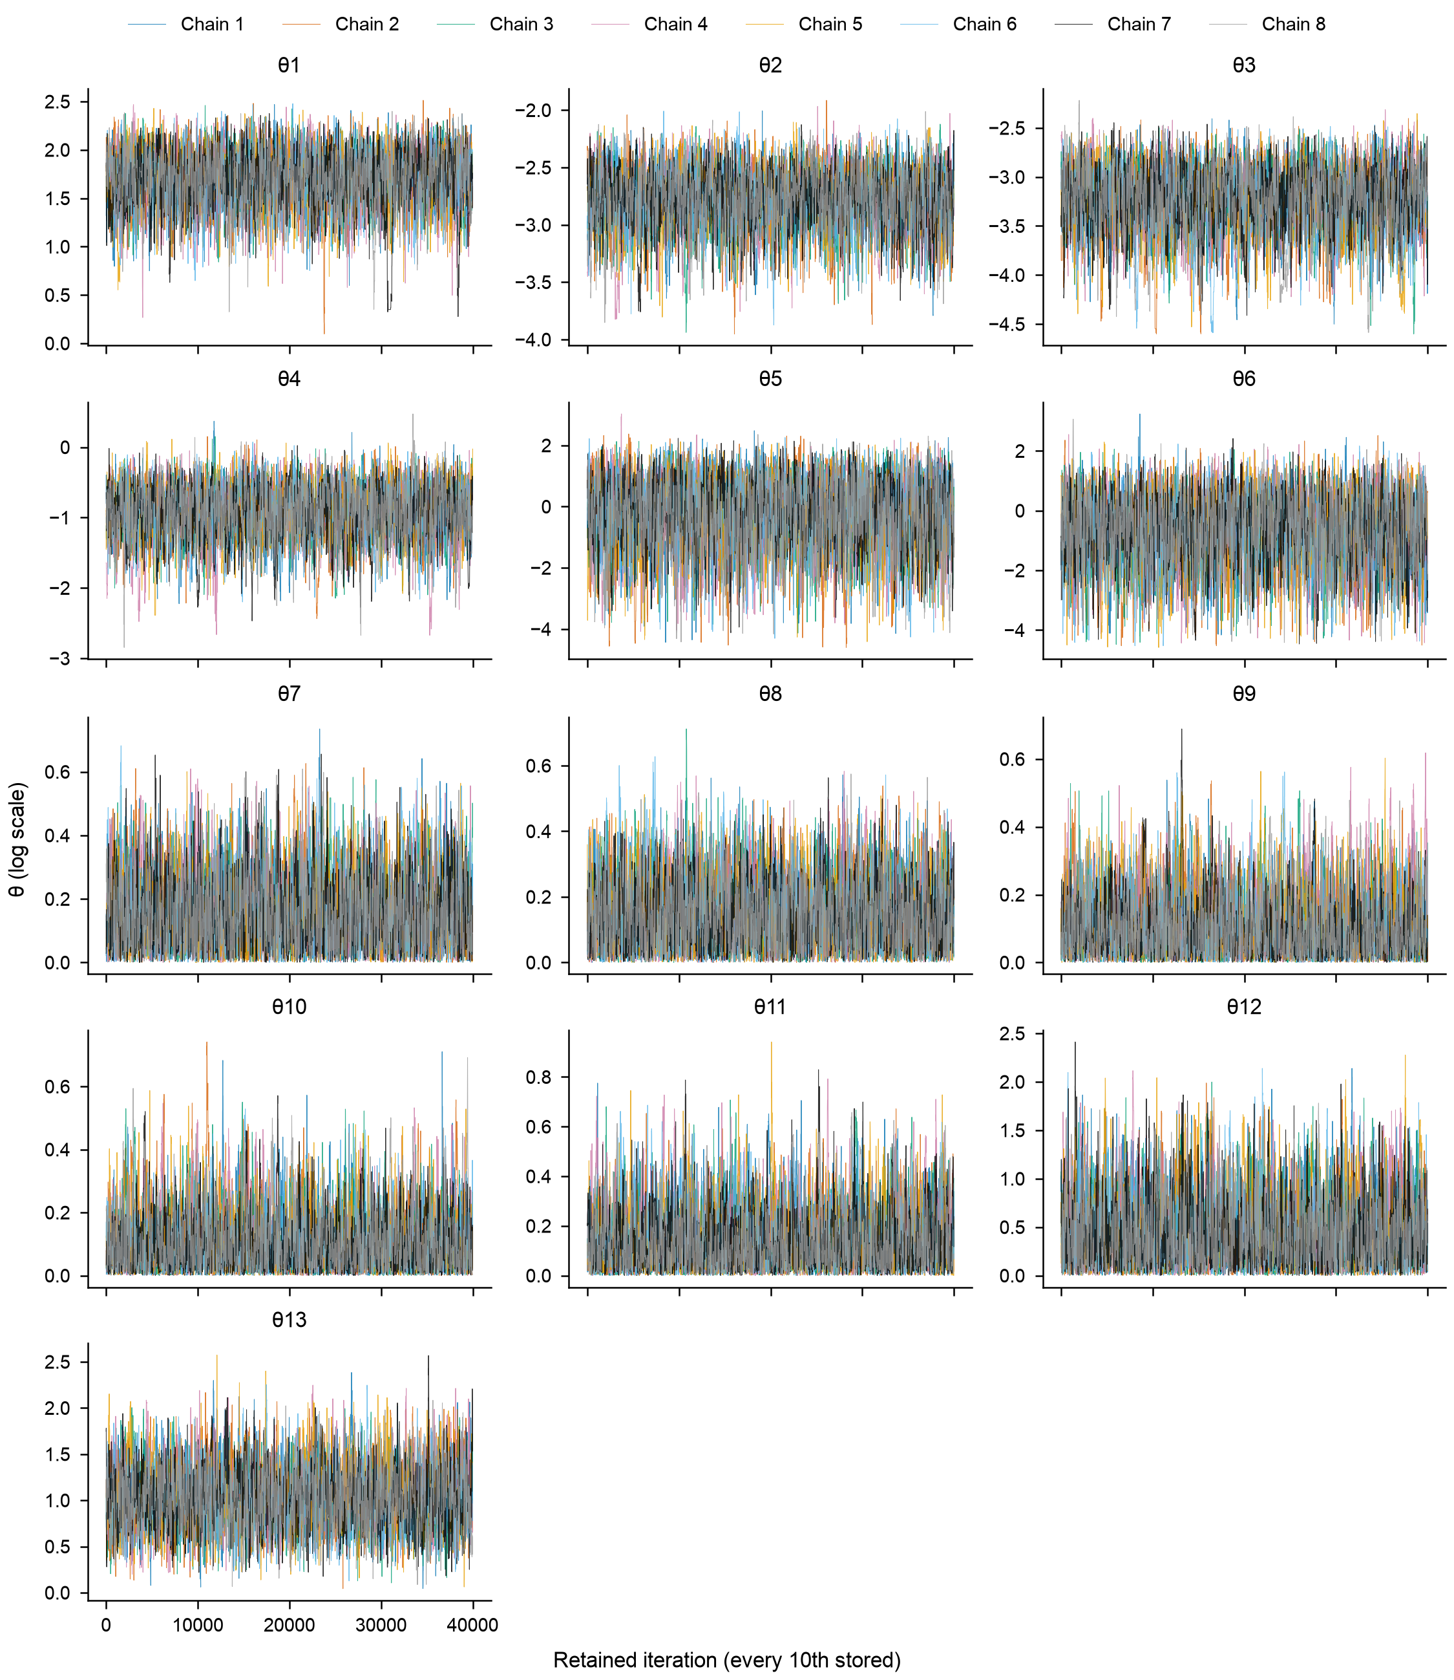
Fig B. Rank histograms of the neural posterior’s simulation-based calibration. 998 data sets, 20 bins; the band is the 99% range under uniformity.
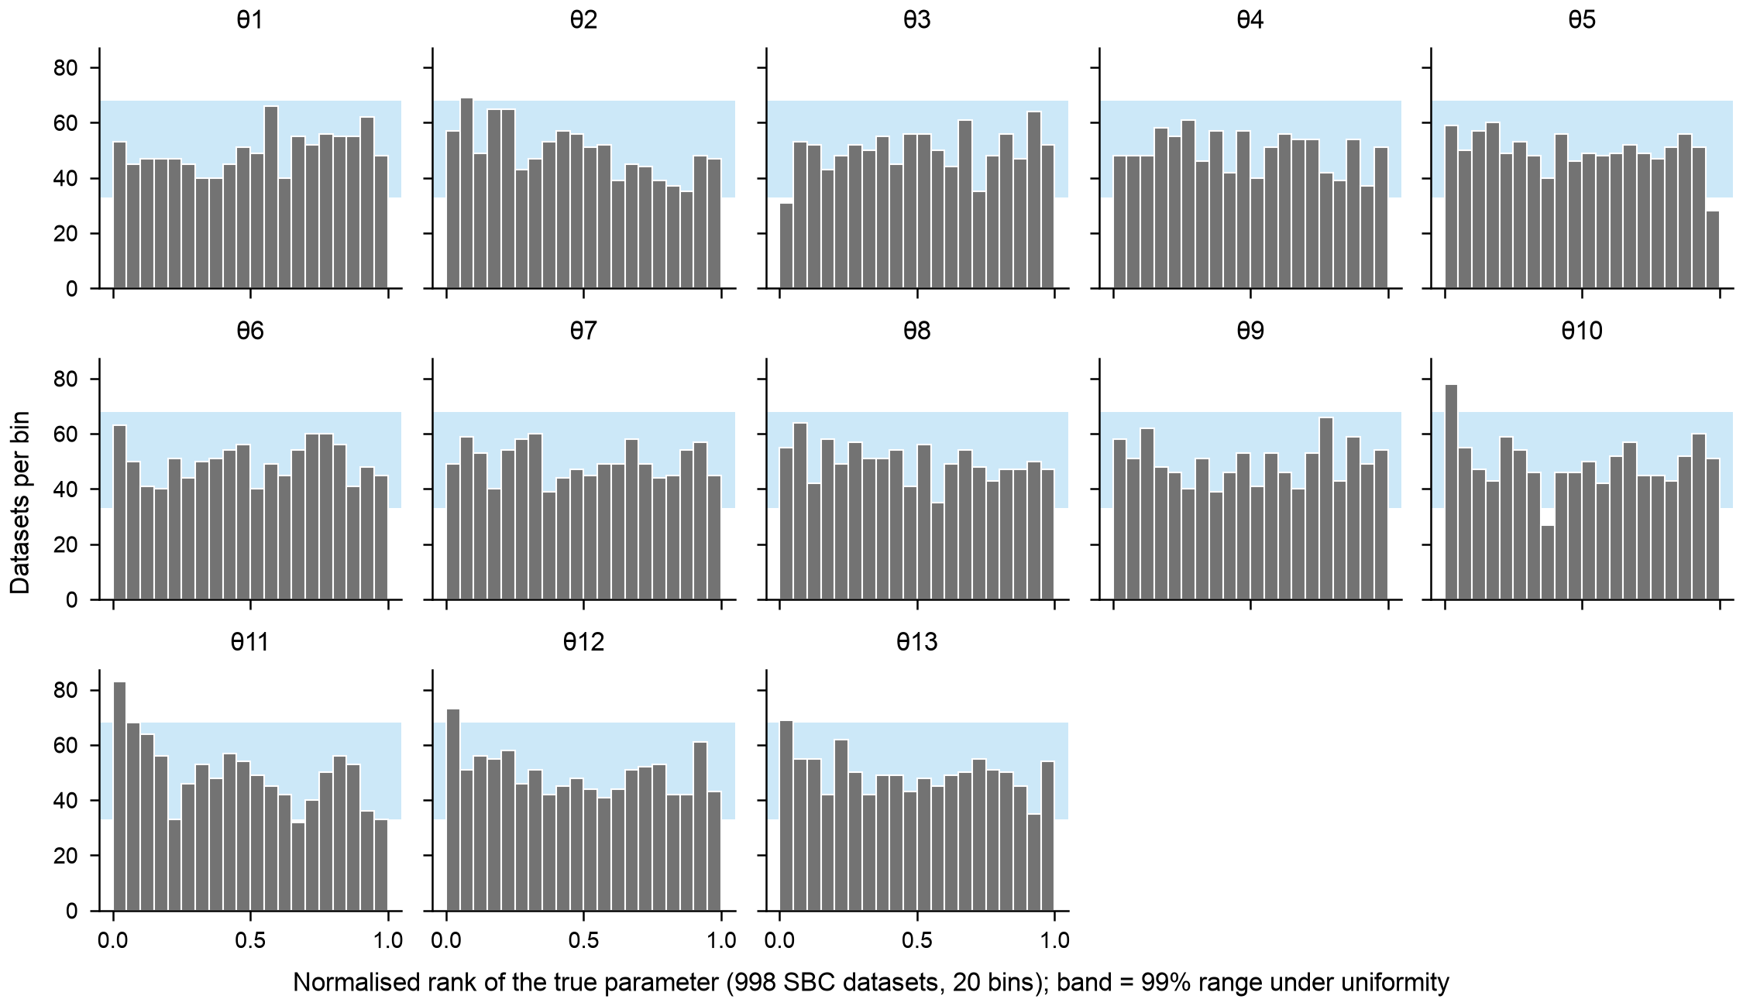
Fig C. Marginal posteriors from the MCMC (grey) and the neural posterior (orange).
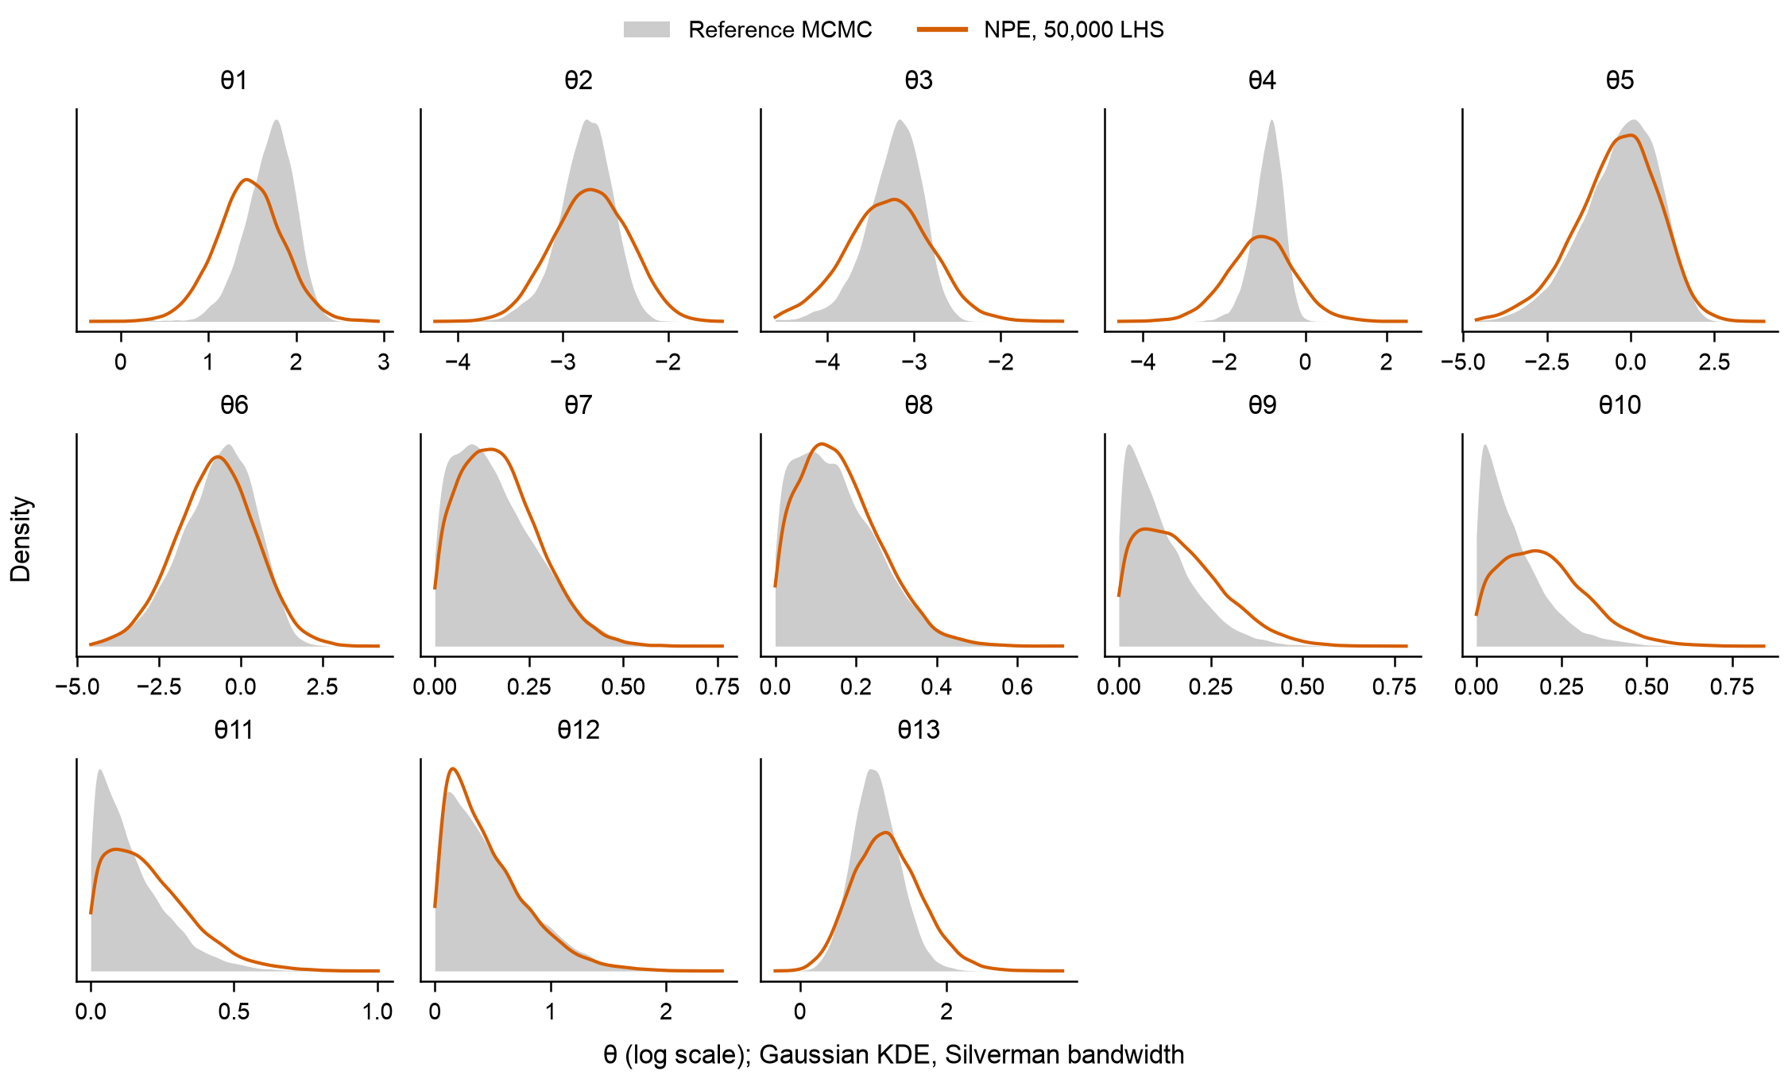
Fig D. Target attainment in 2030 by policy. Median reductions in new infections and HCV deaths, and whether both targets were met.
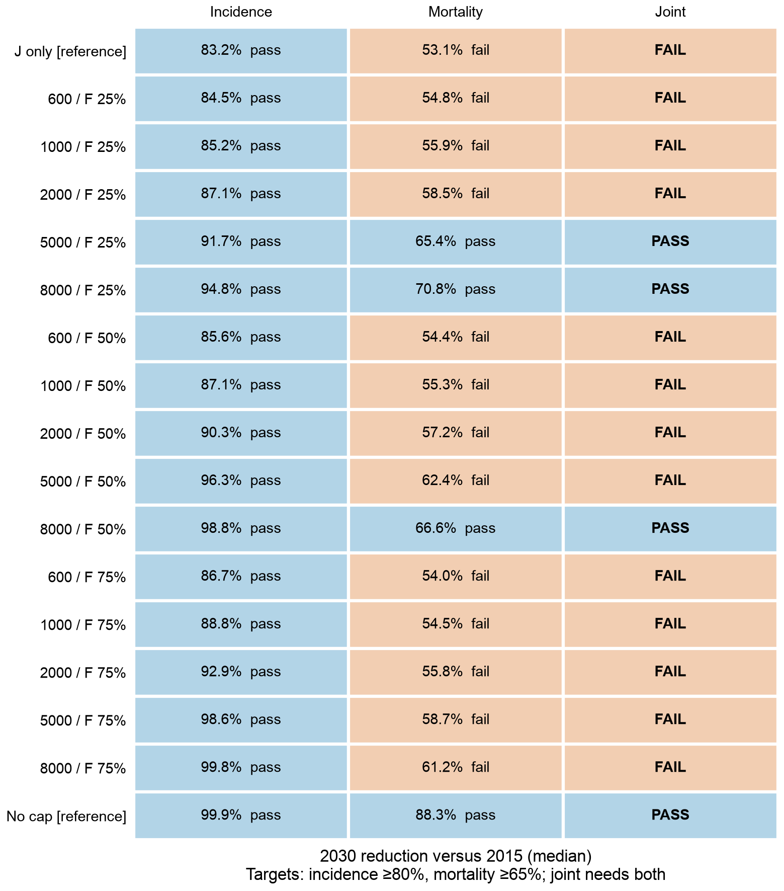
Fig E. Costs and treatment starts, 2026–2030. (A) Discounted costs by group. (B) Undiscounted treatment courses by group. Bars are medians of each group; whiskers are 95% uncertainty intervals of the total.
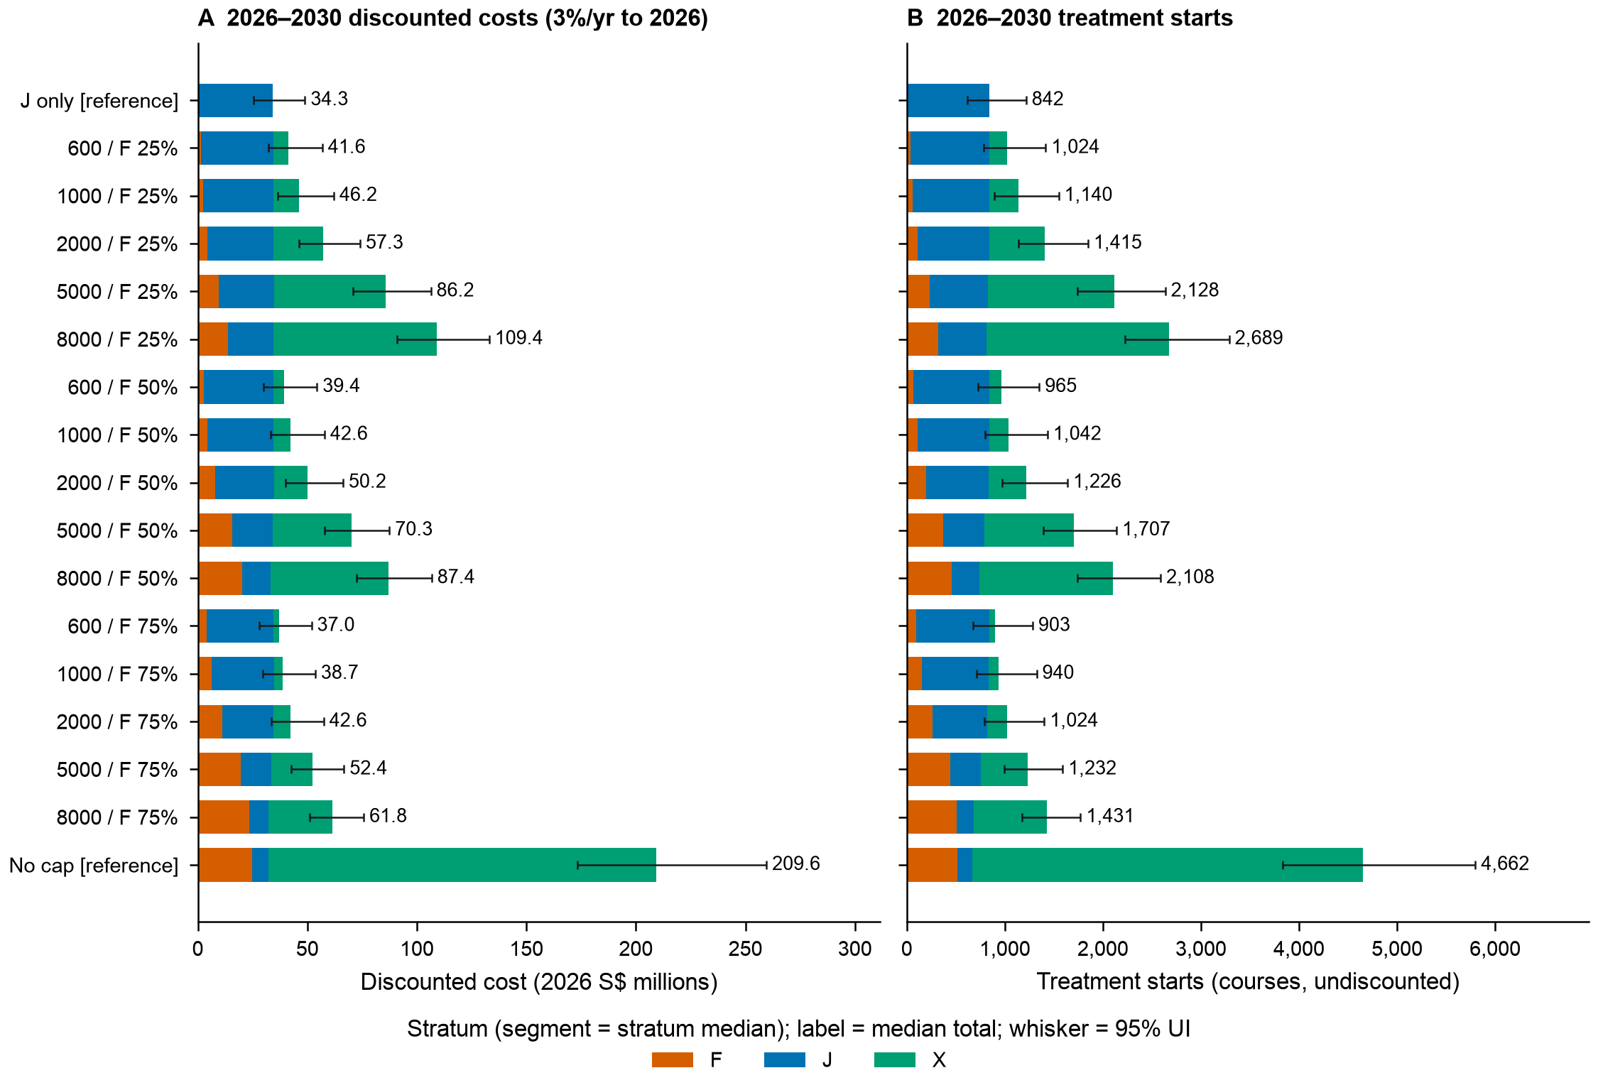
Fig F. Screening cascade in F and X by year. Number screened, RNA tests, RNA-positive people, chronic infections found and treatment starts, by capacity (columns) and share of tests given to F (rows).
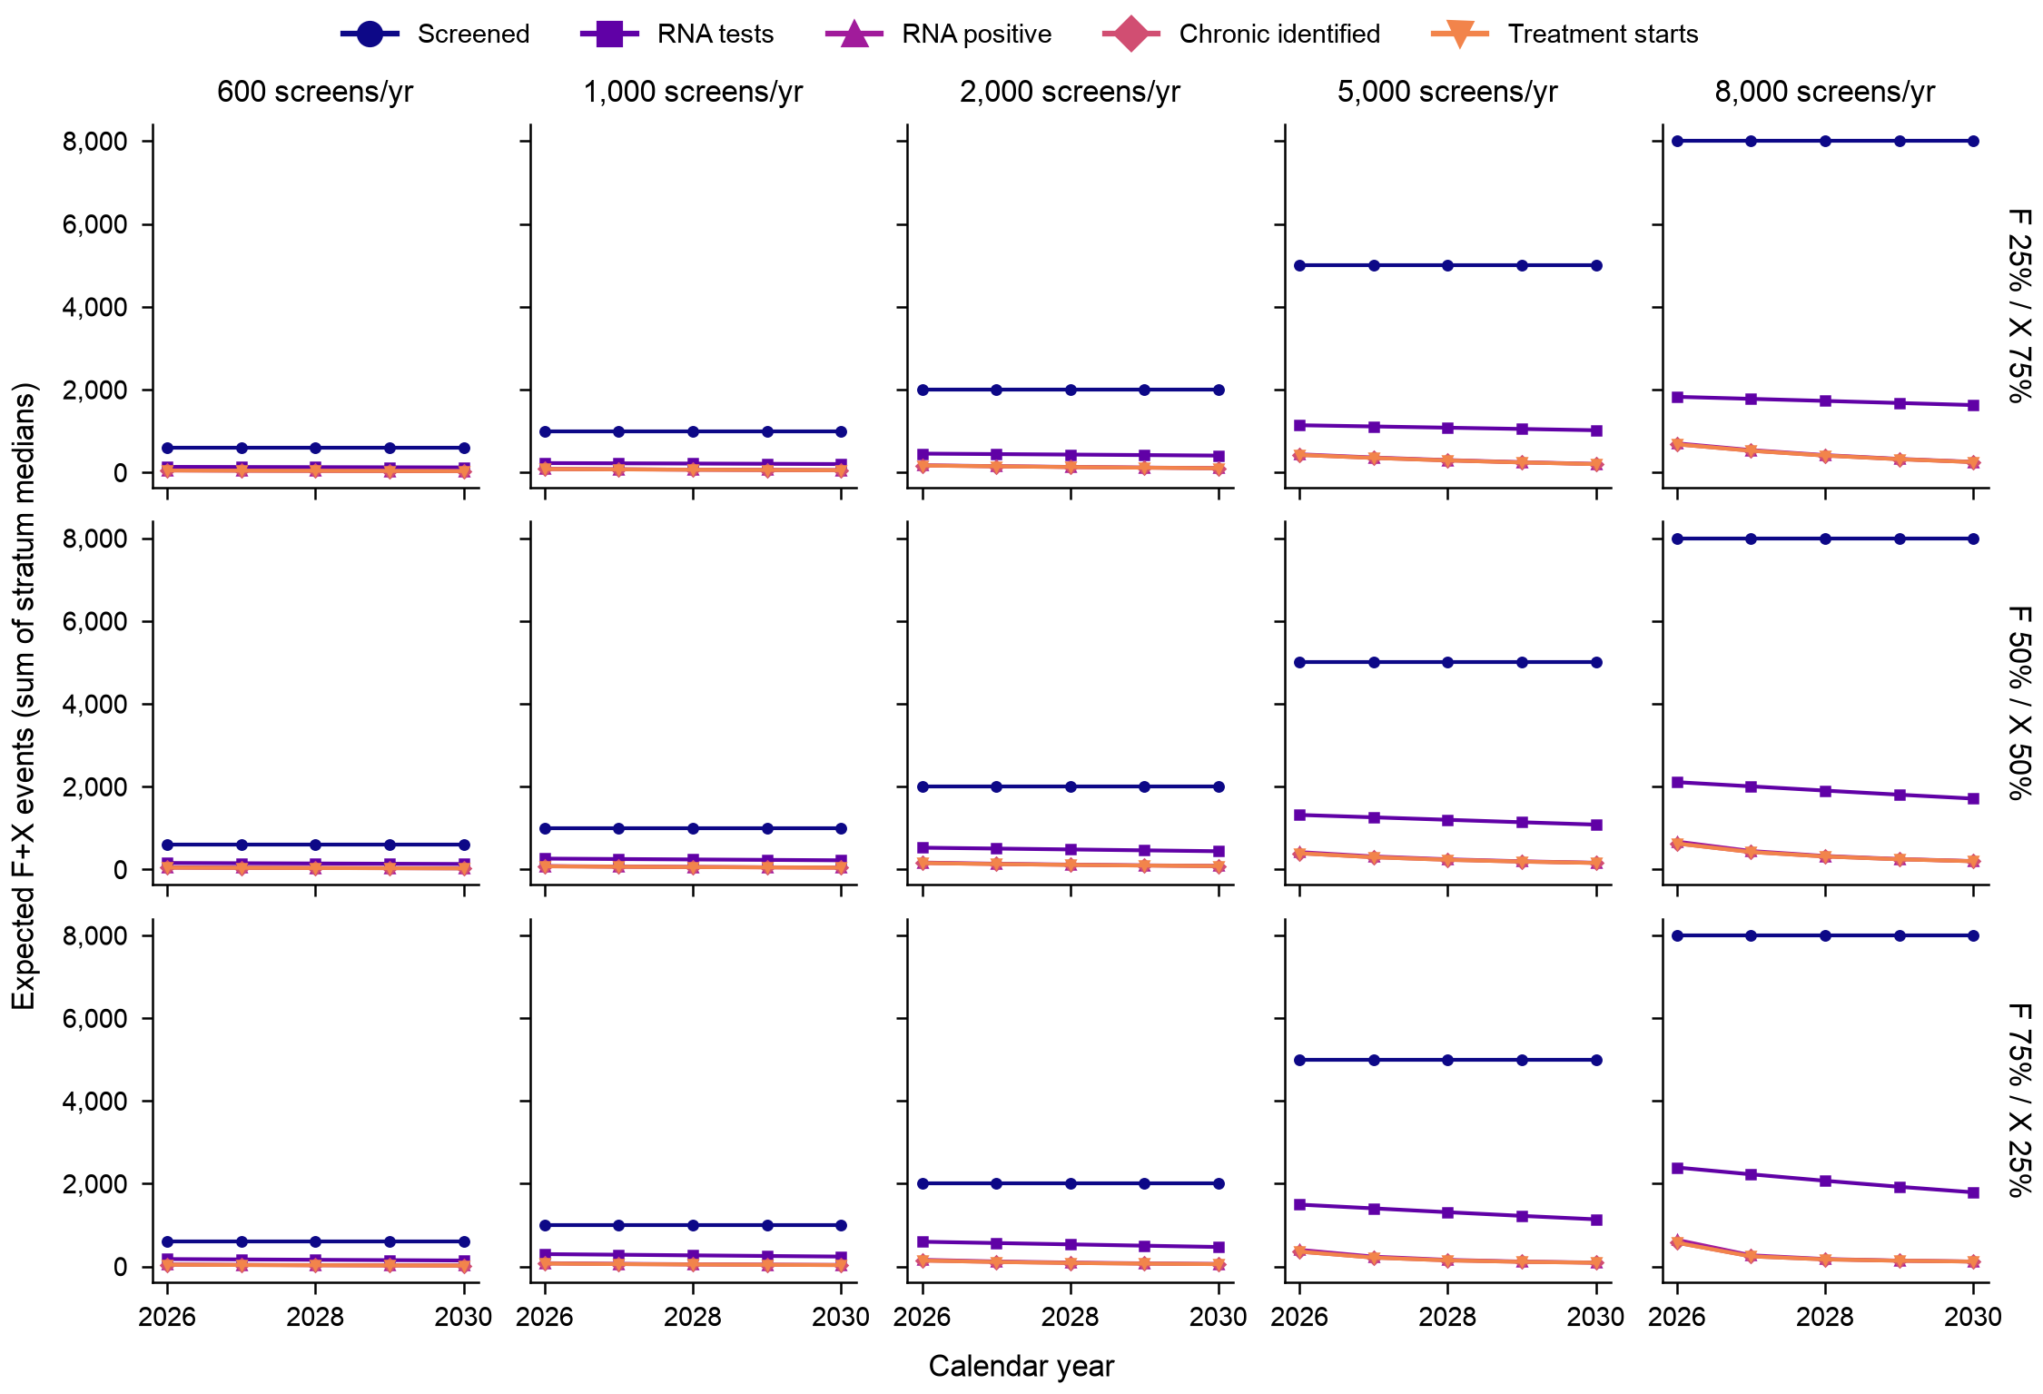

References
1. Boelen L, Teutsch S, Wilson DP, Dolan K, Dore GJ, Lloyd AR, et al. Per-Event Probability of Hepatitis C Infection during Sharing of Injecting Equipment. PLoS ONE. 2014;9: e100749. doi:10.1371/journal.pone.0100749
2. Micallef JM, Kaldor JM, Dore GJ. Spontaneous viral clearance following acute hepatitis C infection: a systematic review of longitudinal studies. Journal of Viral Hepatitis. 2006;13: 34–41. doi:10.1111/j.1365-2893.2005.00651.x
3. Fasano M, Ieva F, Ciarallo M, Caccianotti B, Santantonio TA. Acute Hepatitis C: Current Status and Future Perspectives. Viruses. 2024;16: 1739. doi:10.3390/v16111739
4. Zhao Y, Thurairajah PH, Kumar R, Tan J, Teo EK, Hsiang JC. Novel non-invasive score to predict cirrhosis in the era of hepatitis C elimination: A population study of ex-substance users in Singapore. Hepatobiliary & Pancreatic Diseases International. 2019;18: 143–148. doi:10.1016/j.hbpd.2018.12.002
5. Pawlotsky J-M, Negro F, Aghemo A, Berenguer M, Dalgard O, Dusheiko G, et al. EASL recommendations on treatment of hepatitis C: Final update of the series. Journal of Hepatology. 2020;73: 1170–1218. doi:10.1016/j.jhep.2020.08.018
6. Xiao J, Zhang X, Mao X, Lai S, Li S, Sheng Y. Efficacy and Safety of Velpatasvir Plus Sofosbuvir With or Without Ribavirin in Hepatitis C Patients With Decompensated Cirrhosis: A Systematic Review and Meta‐Analysis. Journal of Viral Hepatitis. 2025;32: e70078. doi:10.1111/jvh.70078
7. Thein H, Yi Q, Dore GJ, Krahn MD. Estimation of stage‐specific fibrosis progression rates in chronic hepatitis C virus infection. Hepatology. 2008;48: 418–431. doi:10.1002/hep.22375
8. Lim AG, Qureshi H, Mahmood H, Hamid S, Davies CF, Trickey A, et al. Curbing the hepatitis C virus epidemic in Pakistan: the impact of scaling up treatment and prevention for achieving elimination. International Journal of Epidemiology. 2018;47: 550–560. doi:10.1093/ije/dyx270
9. Kanwal F, Kramer JR, Ilyas J, Duan Z, El-Serag HB. HCV Genotype 3 Is Associated With an Increased Risk of Cirrhosis and Hepatocellular Cancer in a National Sample of U.S. Veterans With HCV. Hepatology. 2014;60: 98–105. doi:10.1002/hep.27095
10. Meer AJ van der, Veldt BJ, Feld JJ, Wedemeyer H, Dufour J-F, Lammert F, et al. Association Between Sustained Virological Response and All-Cause Mortality Among Patients With Chronic Hepatitis C and Advanced Hepatic Fibrosis. JAMA. 2012;308: 2584–2593. doi:10.1001/jama.2012.144878
11. Morgan RL, Baack B, Smith BD, Yartel A, Pitasi M, Falck-Ytter Y. Eradication of Hepatitis C Virus Infection and the Development of Hepatocellular Carcinoma. Annals of Internal Medicine. 2013;158: 329–337. doi:10.7326/0003-4819-158-5-201303050-00005
12. Premkumar M, Dhiman RK, Duseja A, Mehtani R, Taneja S, Gupta E, et al. Recompensation of Chronic Hepatitis C–Related Decompensated Cirrhosis Following Direct-Acting Antiviral Therapy: Prospective Cohort Study From a Hepatitis C Virus Elimination Program. Gastroenterology. 2024;167: 1429–1445. doi:10.1053/j.gastro.2024.08.018
13. Dang H, Yeo YH, Yasuda S, Huang C, Iio E, Landis C, et al. Cure With Interferon‐Free Direct‐Acting Antiviral Is Associated With Increased Survival in Patients With Hepatitis C Virus‐Related Hepatocellular Carcinoma From Both East and West. Hepatology. 2020;71: 1910–1922. doi:10.1002/hep.30988
14. Santen DK van, Helm JJ van der, Grady BPX, Vos AS de, Kretzschmar MEE, Stolte IG, et al. Temporal trends in mortality among people who use drugs compared with the general Dutch population differ by hepatitis C virus and HIV infection status. AIDS. 2014;28: 2589–2599. doi:10.1097/QAD.0000000000000450
15. Singapore Department of Statistics. Number of drug abusers by age group, annual. data.gov.sg; Available: https://data.gov.sg/datasets/d_f174679381e9085e32869c32bdb01b87/view
16. Teo AKJ, Prem K, Chen MIC, Roellin A, Wong ML, La HH, et al. Estimating the size of key populations for HIV in Singapore using the network scale-up method. Sexually Transmitted Infections. 2019;95: 602–607. doi:10.1136/sextrans-2018-053747
17. Haario H, Saksman E, Tamminen J. An adaptive Metropolis algorithm. Bernoulli. 2001;7: 223–242. doi:10.2307/3318737
18. Vehtari A, Gelman A, Simpson D, Carpenter B, Bürkner P-C. Rank-normalization, folding, and localization: an improved R-hat for assessing convergence of MCMC (with discussion). Bayesian Analysis. 2021;16: 667–718. doi:10.1214/20-BA1221
19. Talts S, Betancourt M, Simpson D, Vehtari A, Gelman A. Validating Bayesian inference algorithms with simulation-based calibration. arXiv preprint. 2018.
20. Greenberg D, Nonnenmacher M, Macke J. Automatic posterior transformation for likelihood-free inference. Proceedings of the 36th international conference on machine learning. 2019. pp. 2404–2414.
21. Tejero-Cantero A, Boelts J, Deistler M, Lueckmann J-M, Durkan C, Gonçalves P, et al. sbi: A toolkit for simulation-based inference. Journal of Open Source Software. 2020;5: 2505. doi:10.21105/joss.02505
22. Papamakarios G, Pavlakou T, Murray I. Masked autoregressive flow for density estimation. Advances in neural information processing systems 30. 2017. pp. 2335–2344.
23. Wong Y, Cheen MH, Hsiang JC, Kumar R, Tan J, Teo EK, et al. Economic evaluation of direct‐acting antivirals for the treatment of genotype 3 hepatitis C infection in Singapore. JGH Open. 2019;3: 210–216. doi:10.1002/jgh3.12139
24. Singapore Department of Statistics. Exchange rates, annual average: SGD per USD. data.gov.sg; Available: https://data.gov.sg/datasets/d_b09aeaf8eb591c4bfe347b66148c6b53/view
25. National Healthcare Group. DSC clinic charges. Available: https://www.nhghealth.com.sg/nsc/about-dsc-clinic/dsc-patient-information/dsc-services/clinic-charges/
26. Parkway Laboratories. Send-out test price list. 2025. Available: https://www.parkwaylabs.com.sg/docs/parkwaylablibraries/test-catalogues/send-out-test-price.pdf
27. Eddelbuettel D, François R. Rcpp: Seamless R and C++ Integration. Journal of Statistical Software. 2011;40: 1–18. doi:10.18637/jss.v040.i08
28. Kassis T, Agarwal V, He Y, Patel D, Brueckner AM. Scientific Agent Skills: A Library of Procedural Knowledge for Research Agents. arXiv:2609.00065; 2026. doi:10.48550/arXiv.2609.00065

